Quarch Technology Ltd

AN-020

Application Note

Module control with config files

For use with:

**Torridon hot-swap / Breaker modules**

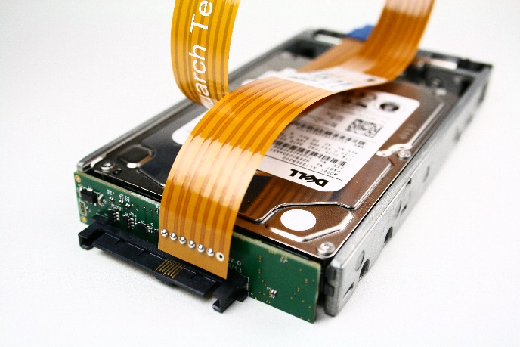

# Change History

|  |  |  |
| --- | --- | --- |
| -01 | March 2020 | Initial Release |
|  |  |  |
|  |  |  |
|  |  |  |
|  |  |  |
|  |  |  |
|  |  |  |
|  |  |  |
|  |  |  |

Contents

Change History 2

Introduction 4

Requirements 5

Application Note Example Files 5

Installation and setup 6

Quarch USB Driver install 6

Python install 6

QuarchPy library install 6

Linux USB Permissions 8

Script example run 9

Customer support from Quarch 11

Access support from the Quarch website 11

Find discussion topics, support information and testing ideas. 11

# Introduction

Quarch modules can be easily automated via their text commands. Each module has differences though: While the main commands are the same, each module has a different list of signals that can be controlled, and some have additional advanced features.

These special cases are described in a set of ‘configuration files’ which are supplied with the quarchpy package. Using a few simple functions, you can locate the config file for your module and use this to list the full capabilities of the device.

This mechanism is used in TestMonkey to provide control over every Quarch module, and is now being released for customer use.

No additional library installs are required (other than quarchpy). Config files will automatically update with quarchpy, as new modules are released

# Requirements

* Python 3.x
* Quarchpy python package
* Quarch breaker/hot-swap module.
  + Power and Switch modules are NOT yet supported, but will come soon

## Application Note Example Files

The **AN-020.zip** should be extracted to your preferred location.

**DeviceCapabilities.py**Simple example, showing how to link the module with the correct configuration file then print out the major parts of the capabilities to the terminal

# Installation and setup

## Quarch USB Driver install

For windows, if you want to use USB control of modules, install the Torridon USB driver:

<https://quarch.com/file/torridon-driver-win8>

Download the file, extract and run the correct installer for your system.

## Python install

If you do not already have Python 3.x installed, download and install it from:

<https://www.python.org/downloads/>

Under Windows it is helpful to make sure the Python installation directory and PythonXX\Scripts are included in the PATH environment variable. See:

<https://docs.python.org/3/using/windows.html#excursus-setting-environment-variables>

## QuarchPy library install

The Quarch Python package can be installed from the Python web repository (assuming you have internet access) or via the download from our website.

QuarchPy includes the latest version of QIS, so no additional install is required

### Web Install

From the command line:

**>pip install quarchpy**

If this fails, your path to “pip” may not be set, you can instead run:

**>python –m pip install quarchpy**

### Local Install

If you want to install from a downloaded folder, ensure the folder is unzipped to a local disk, navigate to the folder containing the setup.py file and run (noting the ‘.’ on the end):

**>pip install quarchpy .**

If this fails, your path to ‘pip’ may not be set, you can instead run:

**>python –m pip install quarchpy .**

### Upgrade

If you already have QuarchPy installed, you will get a failure message. If will need to upgrade to the latest version, you need to add the ‘--upgrade’ command:

**>pip install --upgrade quarchpy**

The --upgrade command can similarly be used in any of the other examples, to load from a local install folder.

## Linux USB Permissions

Linux systems require administrative rights to run python scripts for modules connected via USB. You can do that by running your script as root (sudo command) or changing the default USB permissions. This is done by creating a text file called **Quarch-permissions-usb.rules**

For ubuntu systems, you need to enter into that file:

SUBSYSTEM == “usb”, ATTRS{idVendor}==”16d0”, MODE=”0666”

SUBSYSTEM == “usb_device”, ATTRS{idVendor}==”16d0”, MODE=”0666”

For Centos systems, you need:

SUBSYSTEM == “usb”, ATTRS{idVendor}==”16d0”, GROUP=”users”, MODE=”0666”

SUBSYSTEM == “usb_device”, ATTRS{idVendor}==”16d0”, GROUP=”users”, MODE=”0666”

This file needs to be placed in /etc/udev/rules.d

Finally, the system either needs to be restarted or run the command:

**>sudo udevadm control -reload**

Then reconnect the USB device.

# Script example run

Run the list devices script, to check which modules are available to you

>python DeviceCapabilities.py

First we are asked to select a module to connect to. Only Torridon breaker/hot-swap modules are currently supported

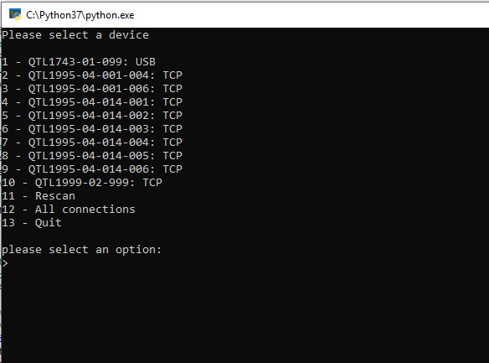

After selecting the module, the script will parse the appropriate file then display a dump of the product’s capabilities

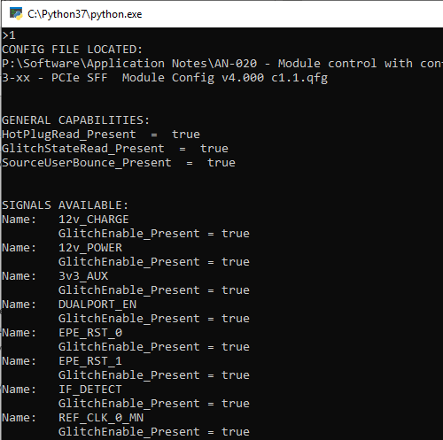

# Customer support from Quarch

There are multiple ways to access the support you need. You can contact us directly or access an extensive range of valuable support materials from <http://quarch.com/support>.

* Contact us direct
* Get going quickly and easily, with help direct from the engineers:
* Call +44 1343 508 140 or email [support@quarch.com](mailto:support@quarch.com) during UK office hours.
* Our international partners are well trained in the use of our products and can deal with many basic technical queries from within your time zone, if you prefer. Check <http://quarch.com/resellers> for the contact details of your regional supplier.

## Access support from the Quarch website

You can download up-to-date software and drivers, technical manuals, datasheets and more from our website. To help you get started quickly we provide additional documents, such as examples in Perl, Python and C# and Telnet and Serial instructions.

* Key **places to visit on** the Quarch website
* Register your Quarch product to confirm your international warranty: <http://quarch.com/product-registration>
* Download a wide range of documentation, free applications and drivers to help you make the best possible use of your Quarch tools: <http://quarch.com/content/downloads>
* Access the Quarch support forum (<http://quarch.com/forum>):

## Find discussion topics, support information and testing ideas.

Browse existing topics or login to your user account to ask for information and advice.

Sign up for Quarch Technical Updates to get the most out of your Quarch products. Updates are published approximately once a quarter and include news about the latest features, tools, application notes and software updates. See <http://quarch.com/content/sign-quarch-technical-updates>.